
MINISTRY FOR EDUCATION AND SCIENCE OF RUSSIA
________________________________

SAINT PETERSBURG ELECTROTECHNICAL UNIVERSITY

«LETI»
________________________________

APPROVED
24/05/2021
__________________________

Name | Date | signature
Bushra Ahmad | 23/05/2021 | 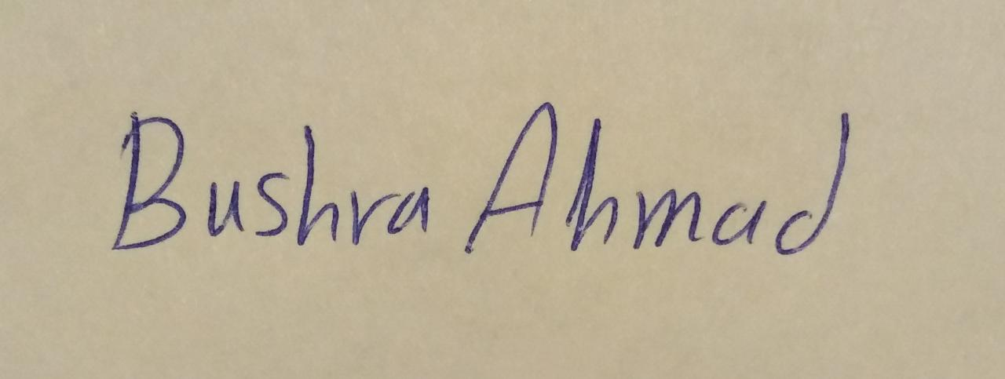
Sarukh Sultan | 23/05/2021 | 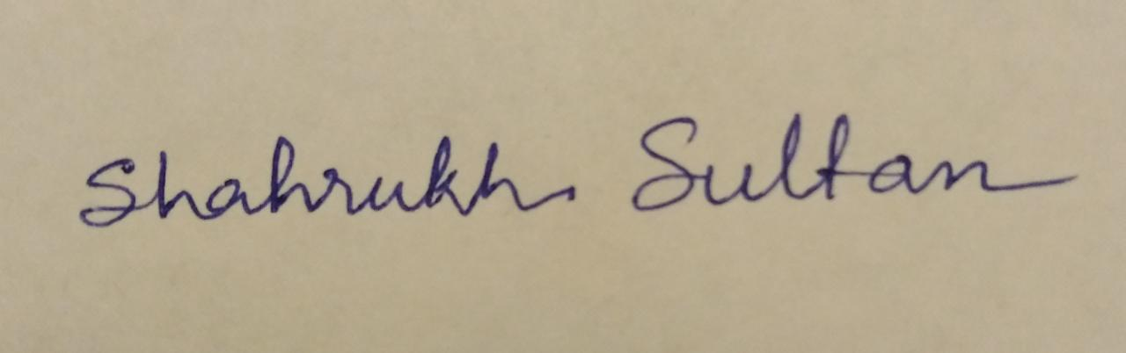

_____________ (( OnMyWay_))_______________________

FINAL REPORT FOR OUR WORK

Report -23/05/2021

St. Petersburg / Санкт-Петербург

2021

Teacher
Filippov Evgeny Vasilyevich / Филиппов Евгений Васильевич e.philippov.leti@mail.ru
Ерошкин Александр Владимирович
a.eroshkin@sigma-it.ru

Content
History 4
Project team 4
Project team 4
Key milstones 5
1. BASIS FOR DEVELOPMENT / 6
2. DEVELOPMENT GOALS / 6
3. HIGH LEVEL REQUIREMENTS / 6
4. Chosen technology and development framework / 6
5. DEVELOPMENT MODEL / 6
Introduction 7
 Detail requirements 7
Dart as a language for coding: 8
Project stakeholders 9
High level Architecture of our project 10
Project goals and vision 11
project specific process 12
Estimation our project by Analog: 13
Use case points: 13
configuration management and version control: 16
Final Metrics : 17
Individual Tasks and Achievements 19
Project Risks 20
Test Plan : 21
Defects: List of Defects Found 21
Result: 22
Conclusion: 23

History

 | Date | Short description
SOW -1- | 04/03/2021 | 1-Name of project  2- Idea of project
SOW -2- | 18/03/2021 | - Project Description  - Basics of development  - High level Architecture
Final SOW | 23/05/2021 | Final Implemantaion App

Project team

№ | Name | Group | Project role | Contact Information
1 | Bushra Ahmad | 6300 | All application | Bushraahmad407146@gmail.com  +79516522218
2 | Shahrukh Sultan | 6300 | All application | getssultan@gmail.com  +91 8638791167

Key milstones

№ | Start date | End date | Description
1 | 01/03/2021 | 18/03/2021 | Determine the project idea and requirements for its application and prepare the tools for its implementation
2 | 2021/03/21 | 2021/04/22 | Learn the Dart language and write the code for designing the user interface and application
3 | 2021/04/23 | 23/05/2021 | Connecting the application with the server, testing the code, and fully realizing the application
4 | 23/05/2021 | 24/05/2021 | Defense

BASIS FOR DEVELOPMENT /
Android studio/framework-flutter/language-dart/API server.
Full name of the project
OnMyWay_________________________________________________________________

DEVELOPMENT GOALS /
The software product is intended to people to give them chance in helping themselves_
If this idea is implemented well, we can reduce congestion and reduce car fuel consumption_______________________________________________________________________________

HIGH LEVEL REQUIREMENTS /
- Technologies used:
- Flutter: To develop the application framework
- Dart: To write the codes
- API Server and Database technologies

_________________________________________________________________________

Chosen technology and development framework /
In this application we use flutter as a framework and dart language for programing

DEVELOPMENT MODEL /
Development model :
We will use the following development model “Agile model”.

Introduction

we want to design an Andriod application , this application will help people in transporting, especially in the countries which transporting isn't available a lot in hole day, so this app make people help themselves and this the Purpose of the system

- Detail requirements

- Requirements:
- Technologies used:
- Flutter: To develop the application framework
- Dart: To write the codes
- API Server and Database technologies

Why we choice the flutter as a framework?
Flutter is an open source software for a suite of software development tools developed by Google to build user interfaces for Android and iOS system applications.

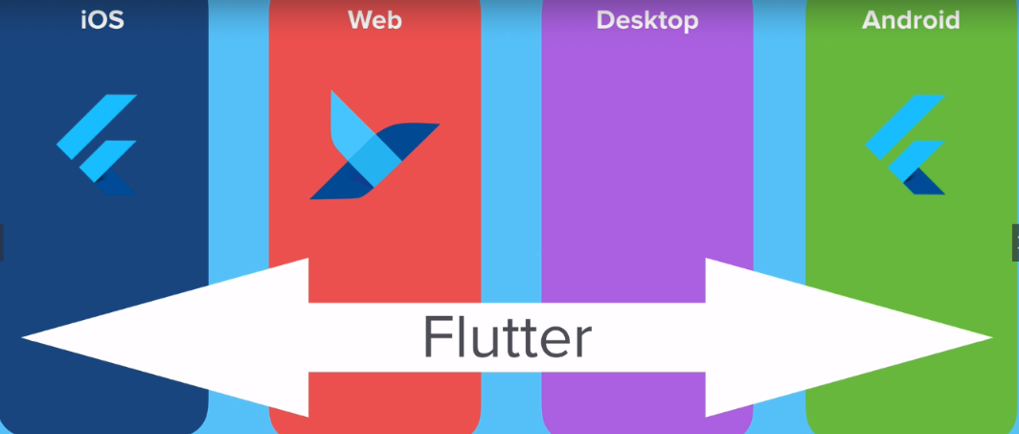

Deal with several screen size

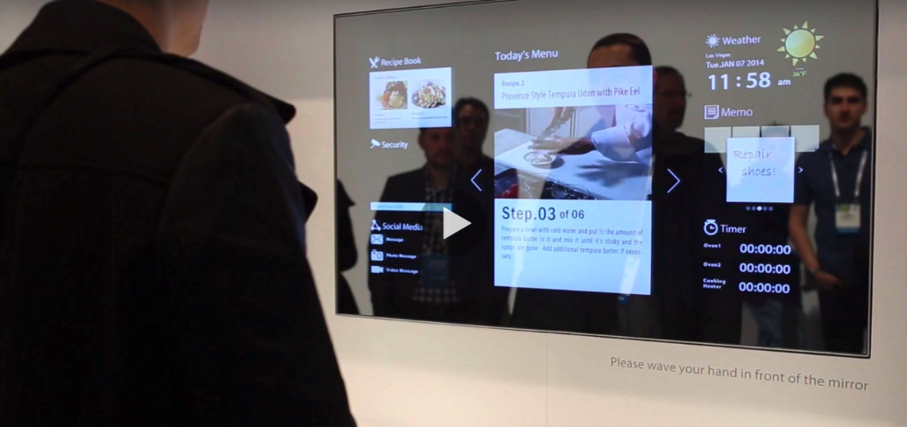

Dart as a language for coding:

- A very flexible language in the sense that you can run it anywhere without any restrictions. You can run Dart applications. For mobile devices on Android - IOS. You can run web applications that you create on any browser
- Multi-platform.
- under developing

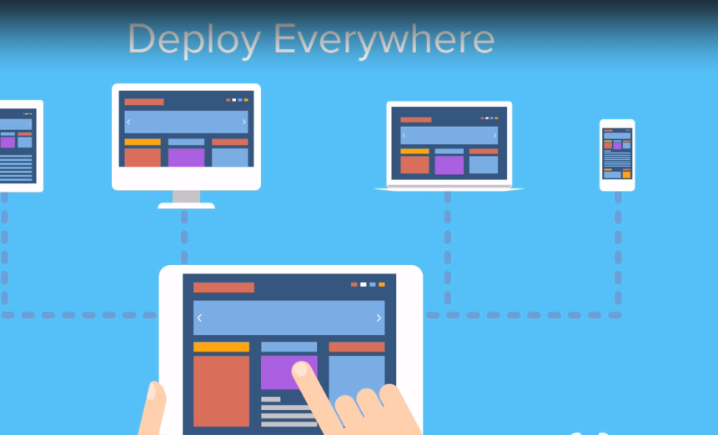

Project stakeholders
When people have the opportunity to move from one place to another, at a time that suits them, and for free, this is what makes the application the focus of everyone's attention
Many people find great happiness in helping others

If this idea is implemented well, we can reduce congestion and reduce car fuel consumption

High level Architecture of our project

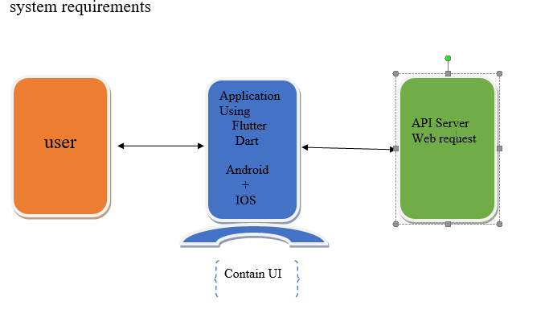
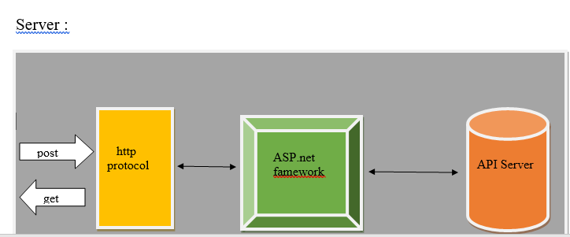
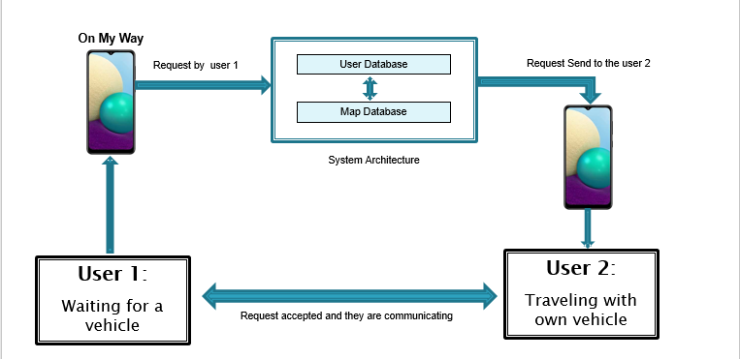

Project goals and vision

Actually there are two important goals to us from this application :
1- let people helping themselves by this type of application.
2- maybe this project isn’t a big project but this subject in this semester will be the first step in software developing world for us so when we apply this application and every thing is ok that mean a lot for us.
3- If this idea is implemented well, we can reduce congestion and reduce car fuel consumption

Total Hours

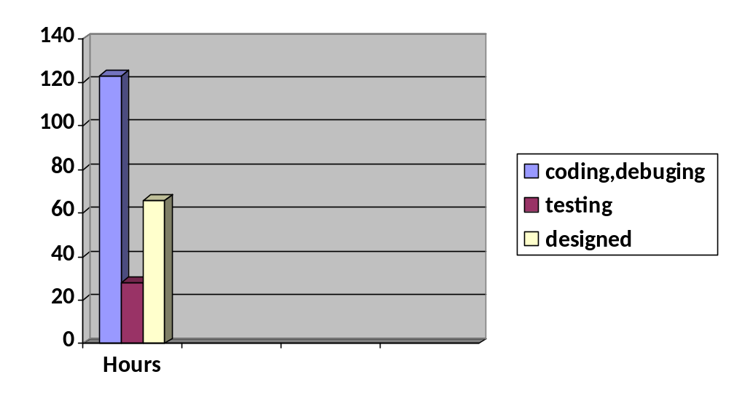

.

project specific process

Development model :
We will use the following development model “Agile model”.

Estimation our project by Analog:

Use case points:
- Number and complexity of actors

Class | Coefficient(ki) | Number of actors(vi)
Simple | 1 | 5
Average | 2 | 3
complex | 3 | 2

Unadjusted Actor Weighting (UAW)=SUM(Ki*Vi)=17

- Number and complexity of use cases

Class | Coefficient(ki) | Number of use cases(vi)
Simple | 5 | 4
Average | 10 | 3
complex | 15 | 2

Unadjusted Use Case Weighting (UUCW) = SUM ( Ki * Vi )=80

- Technical development factor :

Factor | Description | Coefficient (Ki) | Value (Vi)
T1 | Distributed System | 2 | 2
T2 | Response Time | 2 | 5
T3 | End User Efficiency | 1 | 3
T4 | Complex Processing | 1 | 2
T5 | Reusable Code | 1 | 2
T6 | Installation Ease | 0.5 | 3
T7 | Usability | 0.5 | 4
T8 | Portable | 2 | 4
T9 | Easy To Change | 1 | 4
T10 | Highly Concurrent | 1 | 2
T11 | Custom Security | 1 | 2
T12 | Dependence On Third-Party Code | 1 | 1
T13 | User Training | 1 | 5

Technical Complexity Factor (TCF) = 0.6+(0.01*SUM(Ki*Vi))=1.065

- Environmental factor (experience)

Factor | Description | Coefficient (Ki) | Value (Vi)
T1 | Familiarity With The Project Process | 1.5 | 4
T2 | Application Experience | 0.5 | 2
T3 | OO Programming Experience | 1 | 3
T4 | Lead Analyst Capability | 0.5 | 1
T5 | Motivation | 1 | 3
T6 | Stable Requirements | 2 | 2
T7 | Part Time Staff | -1 | 1
T8 | Difficult Programming Language | -1 | 1.5

Environment Factor (EF) = 1.4+(-0.03*SUM(Ki*Vi))=0.95

Use case points : final calculation
UCP = (UAW + UUCW) * TCF * EF =98.13975

configuration management and version control:

For our project we use Github to store the code and other documents.
This the link for our repositoeies:

https://github.com/Shahsul/On_My_Way-SE-Project

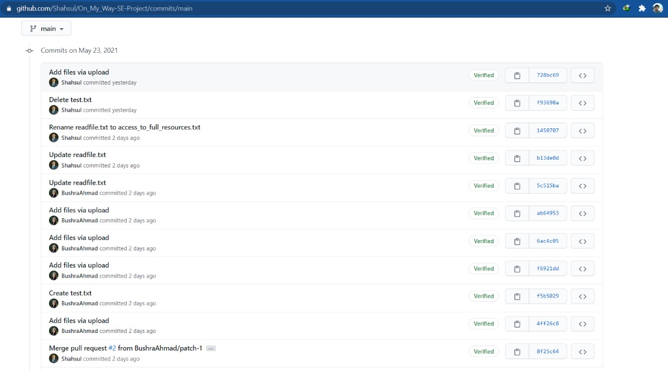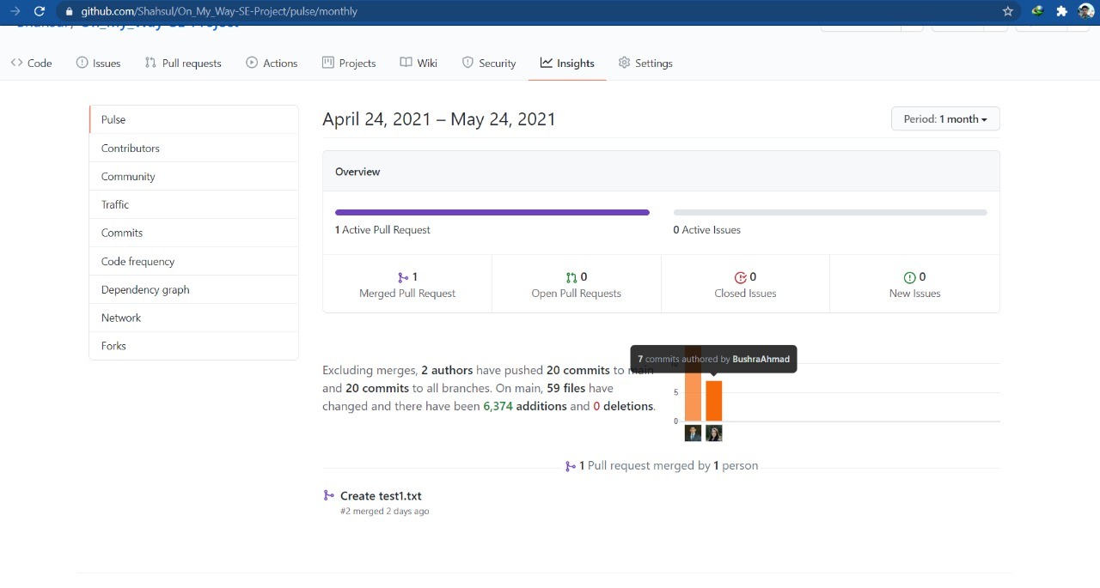

Final project Metrics :

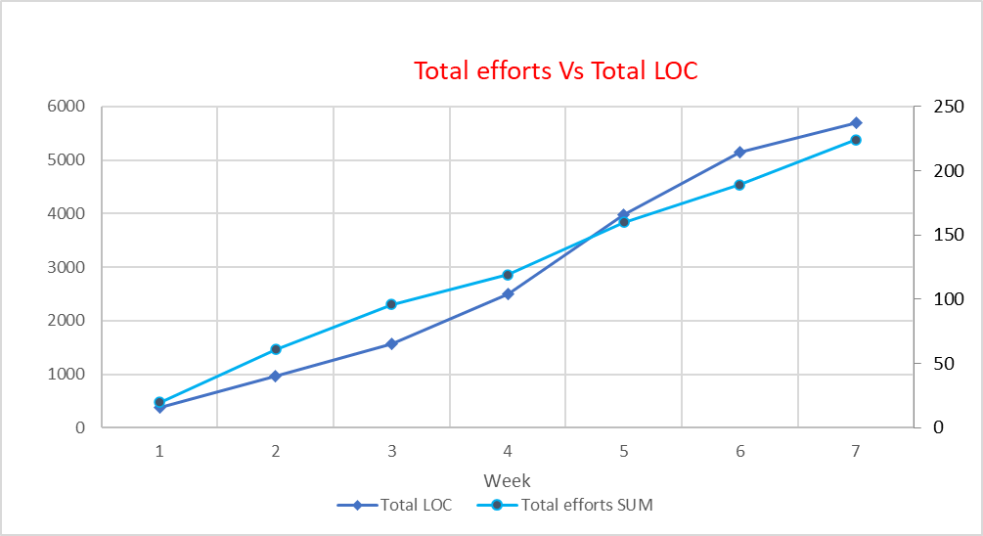

Total number of codes has increased above average during week 5 and till then it was mostly done.

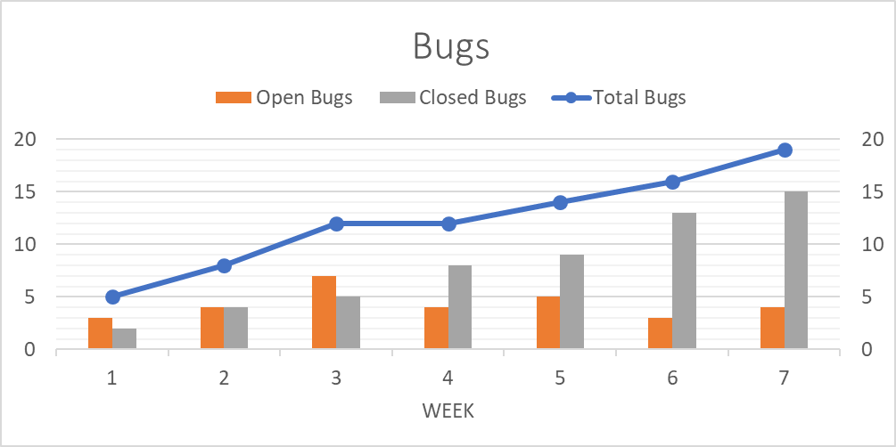

Total number of bugs from starting to beginning is 86, 82 bugs are resolved and 4 bugs are still there.

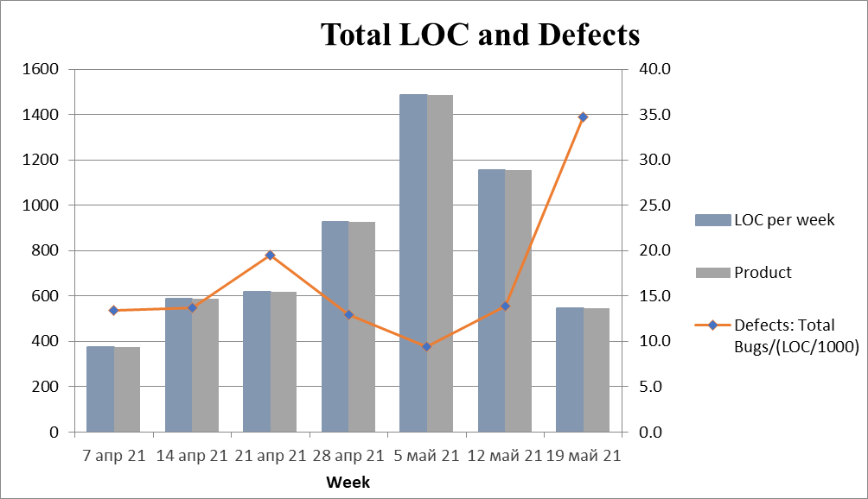

Defect density is high during closing week as repeated tastings were done at the end

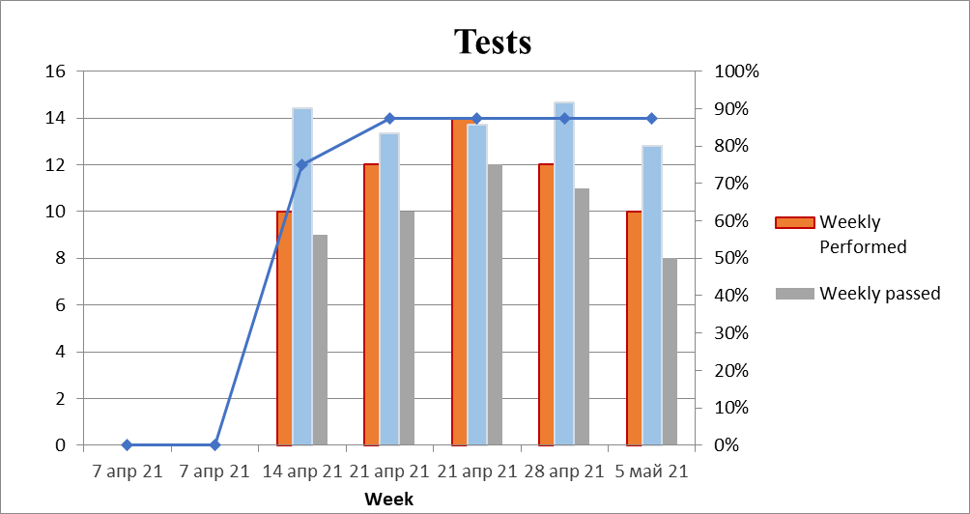

Testing was done mainly by manual debugging and overall performance testing of prototype. Average efficiency is 86.2%

Individual Tasks and Achievements

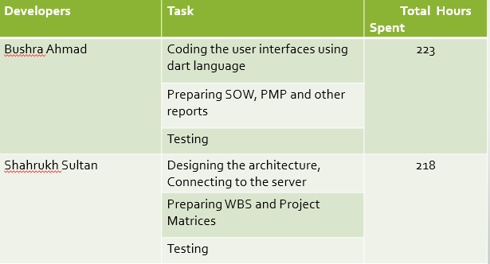

Project Risks

Risk Description | Probability | Impact | severity | Manage the risk | Mitigating action
Due to lack of proper experience and expertise all the objectives is not achieved as expected earlier. | Medium | High | Medium | Project Developer | 1-Taking references from available resources  2- Consult some experts in this field
Due to slow processing of the windows PC the testing and overall development is not time effective | Low | Medium | Medium | Project Developer | Virtual system installation
The application may not be comfortable for all users due to lack of proper information about other end users | Medium | Critical | Medium | Tester | Setting a strong privacy policy

Test Plan :
Test type | Planned Number of tests | Test cases | Test case description
1. Debugging and Framework Testing | 12 | 1.1 | Debugging the source codes and testing the individual user interface in emulator
1. Debugging and Framework Testing | 12 | 1.2 | Testing the overall workflow of the interfaces in emulator
2. Performance testing | 14 | 2.1 | Testing the performance and working speed in a real end user device
3. Server Testing | 14 | 3.1 | Connecting the application with a cloud server and testing the server response.
4. Safety testing | 14 | 4.1 | Security testing about user authentication and user data privacy
5 Usability testing | 14 | 5.1 | Testing the final application in different mobile phones with different specifications

Defects: List of Defects Found

Sl. no | Description | Current state (found, fixed, verified, assigned, open)
1 | Even when the user logs out from the application his sign in details is popped up in the screen, which is a security concern | Open
2 | When the user's internet connection is lost, the application does not warn the user about it | Open
3 | Sometimes seeked services is shown in the "provided services" tab | Found
4 | During registration or sign up the gender selection option takes only "MALE" as input, if someone selects "FEMALE" it doesn't work | Open

Defect statistic on categories

Defect categories | Number  Total / Open
Critical | 2
Major | 2
Regular
Minor
Enhancements

Defect statistic on state

Defect states | Number
Found | 19
Fixed | 15
Verified
Assigned
Open | 4

Result:
Well Implementation:
Attractive and easy user interfaces.
Main objective of the project is achieved.
Drawbacks:
Not enough information for user registration.
Service provider can’t know the information about service seeker.
There is no sufficient information for user authentication so other users may feel insecure to use the services.
The application is not tested for iOS devices due to lack of MAC device.

Future objectives:
Live tracing feature so that the service provider/service seeker user can trace each other live.
Setting more criteria for user authentication and safety.
Live notifications of services to users in a particular location.
Developing a business plan monetization.

Conclusion:

Developing something to fulfill all expectations need expertise. As a beginner level developer it’s a great experience to learn the technical and theoretical requirements throughout the project period. As estimated in the beginning of the project the completion took some few more hours and though the output is not 100% efficient but all the major goals are achieved.

